Apple  Pie  Moonshine  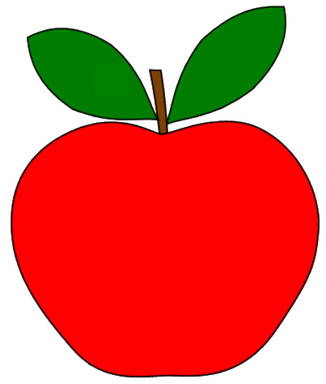 |  | Apple  Pie  Moonshine |  | Apple  Pie  Moonshine
Apple  Pie  Moonshine |  | Apple  Pie  Moonshine |  | Apple  Pie  Moonshine
Apple  Pie  Moonshine |  | Apple  Pie  Moonshine |  | Apple  Pie  Moonshine

