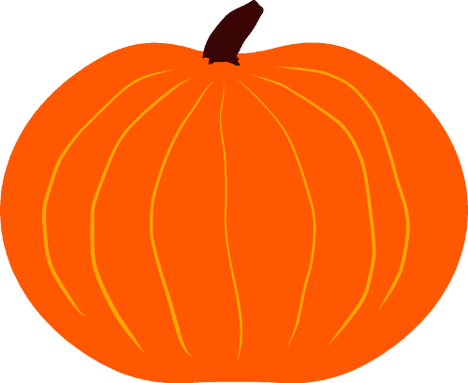  Pumpkin Pie  Moonshine |  | Pumpkin Pie  Moonshine |  | Pumpkin Pie  Moonshine
Pumpkin Pie  Moonshine |  | Pumpkin Pie  Moonshine |  | Pumpkin Pie  Moonshine
Pumpkin Pie  Moonshine |  | Pumpkin Pie  Moonshine |  | Pumpkin Pie  Moonshine

