Strawberry  Moonshine  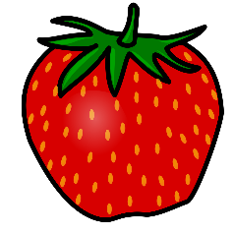 |  | Strawberry  Moonshine |  | Strawberry  Moonshine
Strawberry  Moonshine |  | Strawberry  Moonshine |  | Strawberry  Moonshine
Strawberry  Moonshine |  | Strawberry  Moonshine |  | Strawberry  Moonshine

